***Name: …………………………………***

***Department. :*** *Computer Engineering*

***Class & Semester:*** *B.E (Final Year), Sem VIII*

***Subject:******Distributed Computing Lab (DCL)***

***_________________________________________***

***Expt. No. 01***

***Title:*** *Write a program to demonstrate Datagram Socket for chat application using java.*

***Date:***

***Subject In-charge Sign:***

***…………………………….***

**Experiment No. 01**

**AIM:** Write a program to demonstrate Datagram Socket for chat application using java.

**THEORY:**

**What is Datagram Socket Programming?**

The server continuously receives datagram packets over a datagram socket. Each datagram packet received by the server indicates a client request for a quotation. When the server receives a datagram, it replies by sending a datagram packet that contains a one-line "quote of the moment" back to the client.

The client application in this example is fairly simple. It sends a single datagram packet to the server indicating that the client would like to receive a quote of the moment. The client then waits for the server to send a datagram packet in response.

Socket is an interface between an application process and transport layer. The application process can send/receive messages to/from another application process (local or remote) via a socket.

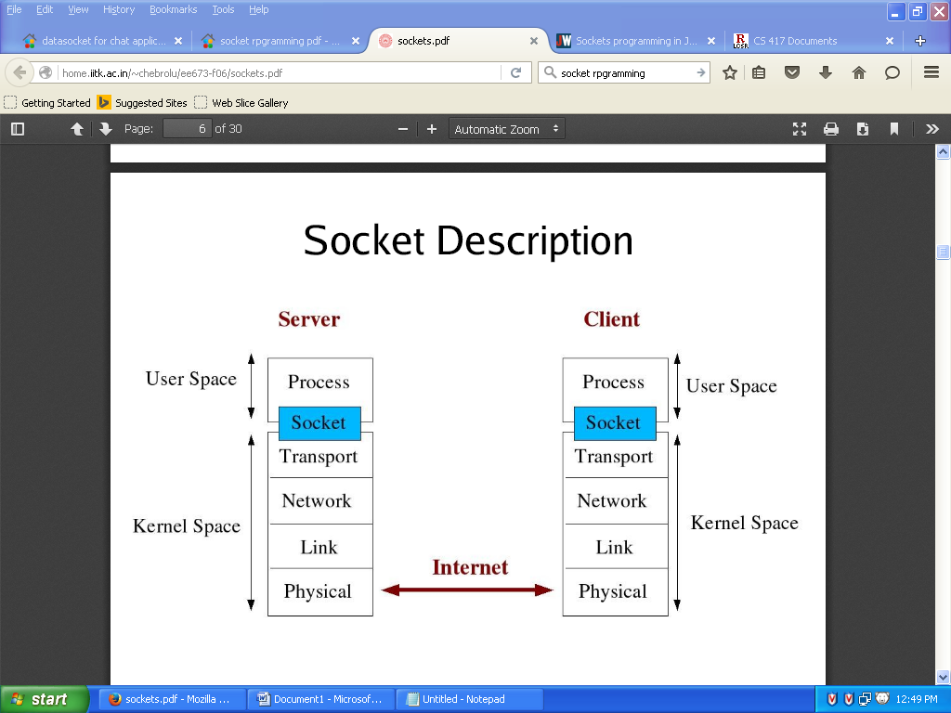

There are a few steps involved in using sockets:

* **Create the socket**
* **Identify the socket**
* **On the server, wait for an incoming connection**
* **On the client, connect to the server's socket**
* **Send and receive messages**
* **Close the socket**

**ALGORITHM:**

datagramsocket,datagrampacket,BufferedReader,InetAddress.  
Start the main function  
In the main function using while loop it perform the loop until str.equals is STOP  
There important while loop function are  
clientsocket = new DatagramSocket(cport);  
dp = new DatagramPacket(buf, buf.length);  
dis = new BufferedReader(new  
InputStreamReader(System.in));  
ia = InetAddress.getLocalHost(); f it is stop then break the while loop

**PROGRAM:**

// Source code java programming Datagram Chat Client

**import** java**.**io**.*;**

**import** java**.**net**.*;**

class DatagramClient

**{**

public static DatagramSocket clientsocket**;**

public static DatagramPacket dp**;**

public static BufferedReader dis**;**

public static InetAddress ia**;**

public static byte buf**[]** **=** **new** byte**[**1024**];**

public static int cport **=** 789**,** sport **=** 790**;**

public static void main**(**String**[]** a**)** **throws** IOException

**{**

clientsocket **=** **new** DatagramSocket**(**cport**);**

dp **=** **new** DatagramPacket**(**buf**,** buf**.**length**);**

dis **=** **new** BufferedReader**(new** InputStreamReader**(**System**.**in**));**

ia **=** InetAddress**.**getLocalHost**();**

System**.**out**.**println**(**"Client is Running... Type stop to Quit"**);**

**while(true)**

**{**

String str **=** **new** String**(**dis**.**readLine**());**

buf **=** str**.**getBytes**();**

**if(**str**.**equals**(**"STOP"**))**

**{**

System**.**out**.**println**(**"Terminated..."**);**

clientsocket**.**send**(new**

DatagramPacket**(**buf**,**str**.**length**(),** ia**,**sport**));**

**break;**

**}**

clientsocket**.**send**(new** DatagramPacket**(**buf**,**

str**.**length**(),** ia**,** sport**));**

clientsocket**.**receive**(**dp**);**

String str2 = new String(dp.getData(), 0,

dp.getLength());

System.out.println("Server: " + str2);

}

}

}

//Source code java programming Datagram Chat Server

**import** java**.**io**.*;**

**import** java**.**net**.*;**

class DatagramServer

**{**

public static DatagramSocket serversocket**;**

public static DatagramPacket dp**;**

public static BufferedReader dis**;**

public static InetAddress ia**;**

public static byte buf**[]** **=** **new** byte**[**1024**];**

public static int cport **=** 789**,**sport**=**790**;**

public static void main**(**String**[]** a**)** **throws** IOException

**{**

serversocket **=** **new** DatagramSocket**(**sport**);**

dp **=** **new** DatagramPacket**(**buf**,**buf**.**length**);**

dis **=** **new** BufferedReader

**(new** InputStreamReader**(**System**.**in**));**

ia **=** InetAddress**.**getLocalHost**();**

System**.**out**.**println**(**"Server is Running..."**);**

**while(true)**

**{**

serversocket**.**receive**(**dp**);**

String str **=** **new** String**(**dp**.**getData**(),** 0**,**

dp**.**getLength**());**

**if(**str**.**equals**(**"STOP"**))**

**{**

System**.**out**.**println**(**"Terminated..."**);**

**break;**

**}**

System**.**out**.**println**(**"Client: " **+** str**);**

String str1 **=** **new** String**(**dis**.**readLine**());**

buf **=** str1**.**getBytes**();**

serversocket.send(new

DatagramPacket(buf,str1.length(), ia, cport));

}

}

}

**OUTPUT:**

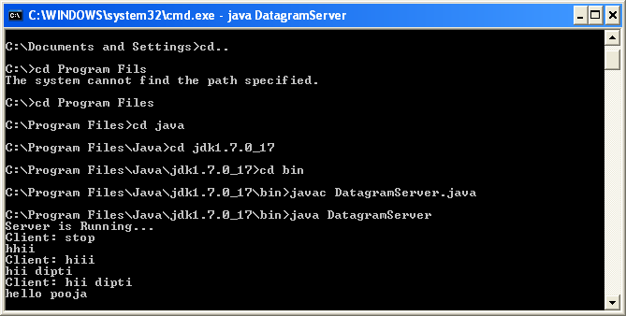

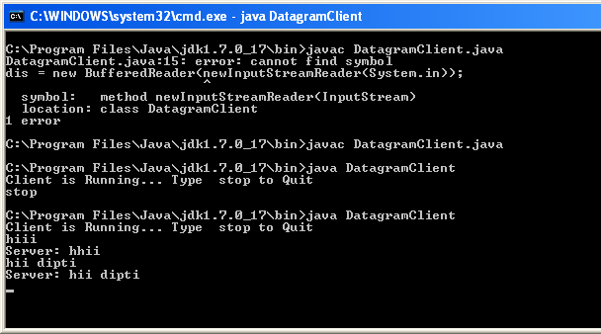

**CONCLUSION:**

Thus we have studied the program to demonstrate Datagram program for chat application.